Project Design Phase
Solution Architecture

Date | 15 February 2025
Team ID | LTVIP2026TMIDS82222
Project Name | HouseHunt – Finding Your Perfect Rental Home
Maximum Marks | 4 Marks

Solution Architecture:

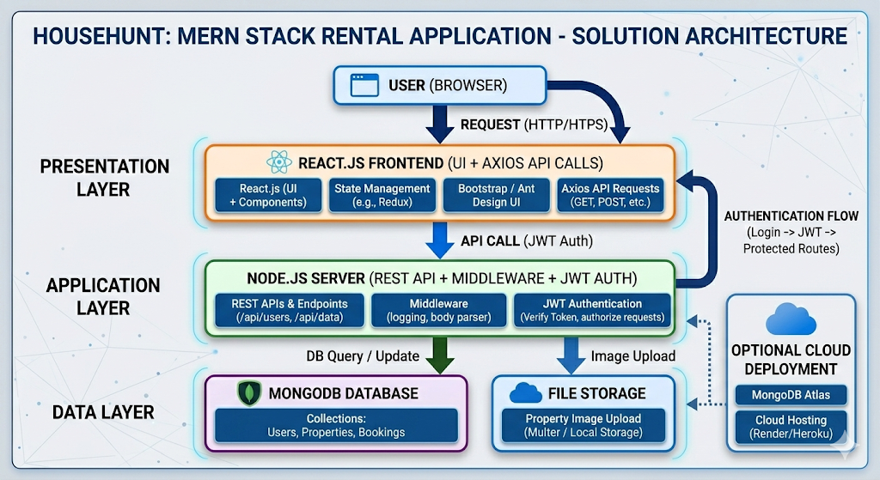

Figure 1: Architecture and data flow of the house rant application

